SCHOOL OF COMPUTER SCIENCE AND ARTIFICIAL INTELLIGENCE |  |  |  |  | DEPARTMENT OF COMPUTER SCIENCE ENGINEERING
Program Name: B. Tech |  |  |  | Assignment Type: Lab |  |  | Academic Year:2025-2026
Course Coordinator Name |  |  |  | Dr. Rishabh Mittal
Instructor(s) Name |  |  |  | Mr. S Naresh Kumar  Ms. B. Swathi  Dr. Sasanko Shekhar Gantayat  Mr. Md Sallauddin  Dr. Mathivanan  Mr. Y Srikanth  Ms. N Shilpa  Dr. Rishabh Mittal (Coordinator)  Dr. R. Prashant Kumar  Mr. Ankushavali MD  Mr. B Viswanath  Ms. Sujitha Reddy  Ms. A. Anitha  Ms. M.Madhuri  Ms. Katherashala Swetha  Ms. Velpula sumalatha  Mr. Bingi Raju
Course Code |  |  | 23CS002PC304 | Course Title |  | AI Assisted Coding
Year/Sem |  |  | III/II | Regulation |  | R23
Date and Day  of Assignment |  |  | Week6 – Wednesday | Time(s) |  | 23CSBTB01 To 23CSBTB52
Duration |  |  | 2 Hours | Applicable to  Batches |  | All batches
Assignment Number:11.3(Present assignment number)/24(Total number of assignments)
 | Q.No. | Question |  |  |  |  |  | Expected Time  to complete
 | 1 | Lab 11: Data Structures with AI Implementing Fundamental Data Structures using AI Assistance  Lab Objectives:  By the end of this lab, students will be able to:  - Design and implement fundamental data structures in Python using AI assistance.  - Effectively prompt AI tools (e.g., GitHub Copilot) for code generation, optimization, and documentation.  - Understand and compare core data structures: Arrays, Linked Lists, Stacks, Queues, Priority Queues, Trees, and Graphs.  - Improve code readability, efficiency, and maintainability using AI-generated suggestions.  Learning Outcomes  After completing this lab, students will be able to:  - Apply appropriate data structures to solve real-world problems.  - Analyze time and space complexity of different data structure operations.  - Use AI tools responsibly to assist (not replace) logical thinking and problem-solving.  - Validate, test, and refine AI-generated code.  Task 1: Smart Contact Manager (Arrays & Linked Lists)  Scenario  SR University’s student club requires a simple Contact Manager Application to store members’ names and phone numbers. The system should support efficient addition, searching, and deletion of contacts.  Tasks  - Implement the contact manager using arrays (lists).  - Implement the same functionality using a linked list for dynamic memory allocation.  - Implement the following operations in both approaches:  - Add a contact  - Search for a contact  - Delete a contact  - Use GitHub Copilot to assist in generating search and delete methods.  - Compare array vs. linked list approaches with respect to:  - Insertion efficiency  - Deletion efficiency  Expected Outcome  - Two working implementations (array-based and linked-list-based).  - A brief comparison explaining performance differences.  Prompt:-  Code:-  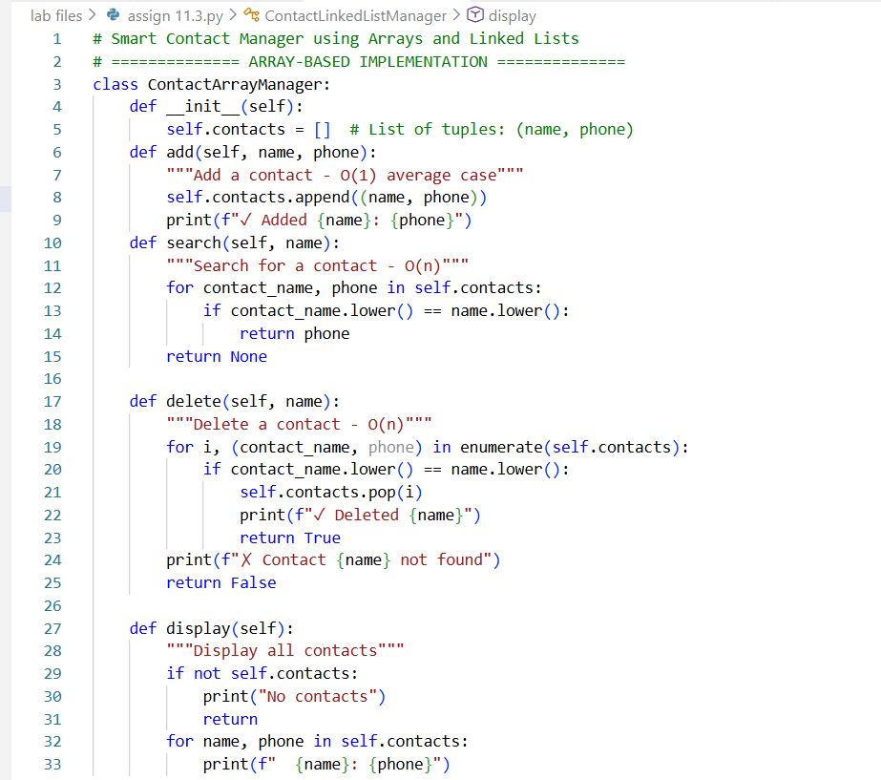  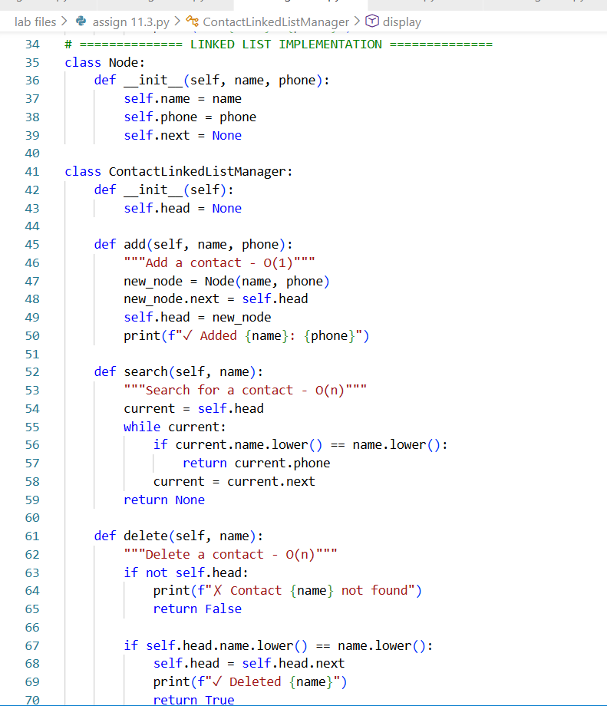  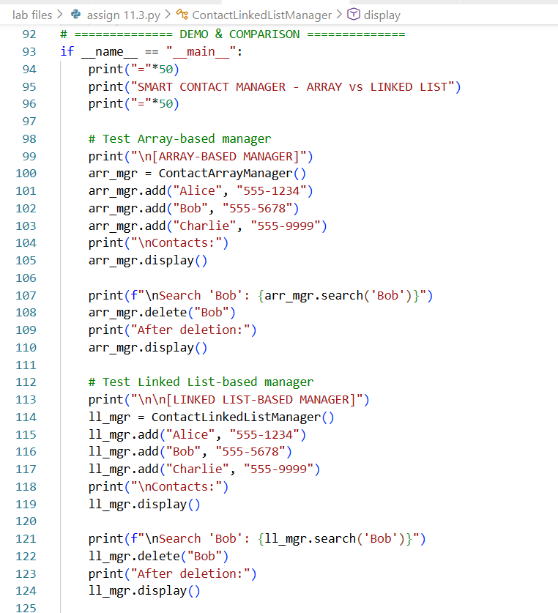  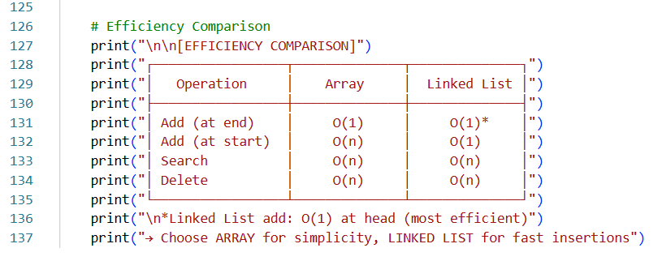Output:-  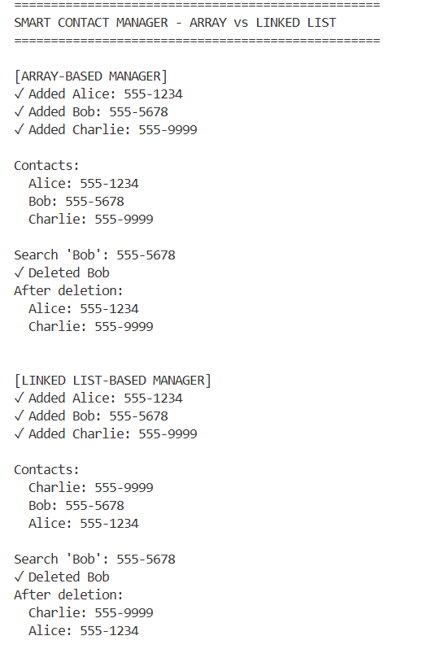  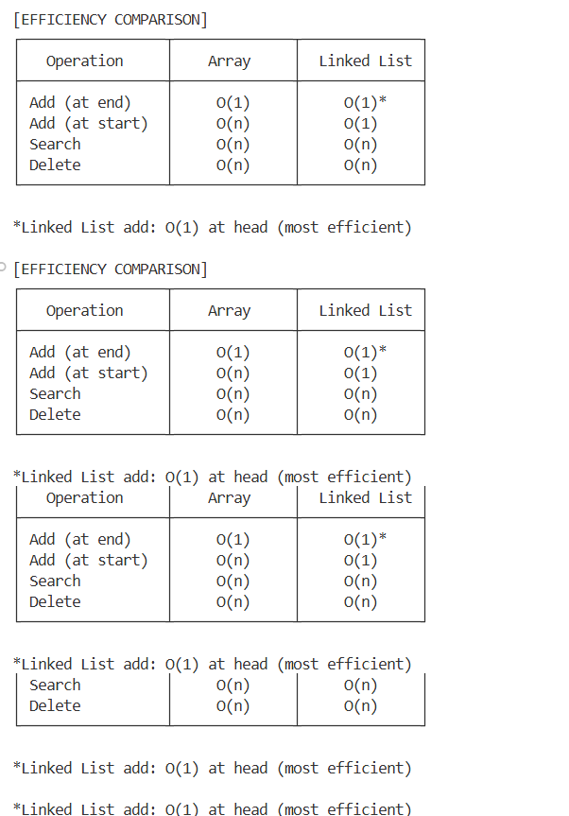  Explanation:-  Smart Contact Manager stores names and phone numbers using arrays and linked lists. Arrays make adding and searching easy, but deleting a contact takes more time due to shifting. Linked lists store contacts as connected nodes, making insertion and deletion faster. This task helps compare how both structures perform  Task 2: Library Book Search System (Queues & Priority Queues)  Scenario  The SRU Library manages book borrow requests. Students and faculty submit requests, but faculty requests must be prioritized over student requests.  Tasks  - Implement a Queue (FIFO) to manage book requests.  - Extend the system to a Priority Queue, prioritizing faculty requests.  - Use GitHub Copilot to assist in generating:  - enqueue() method  - dequeue() method  - Test the system with a mix of student and faculty requests.  Expected Outcome  - Working queue and priority queue implementations.  - Correct prioritization of faculty requests.  Prompt:-  Code:-  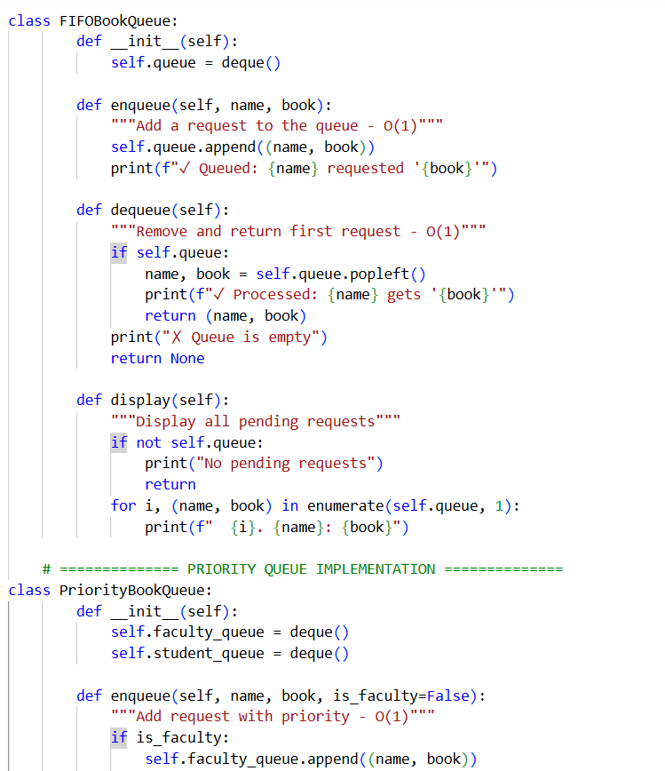  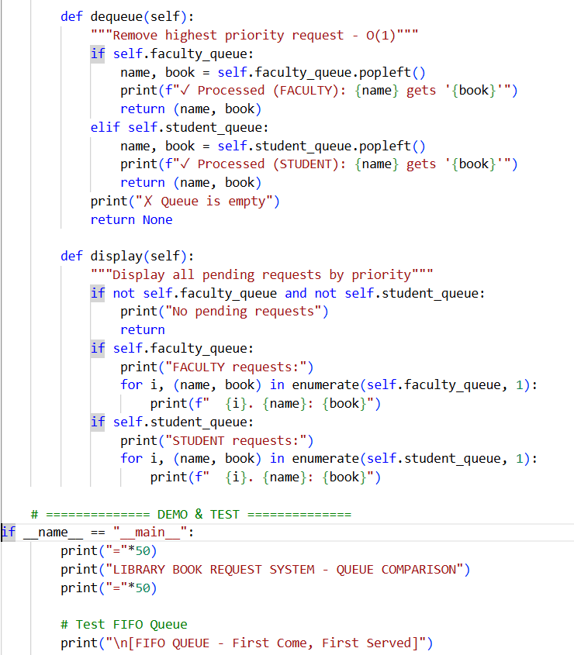  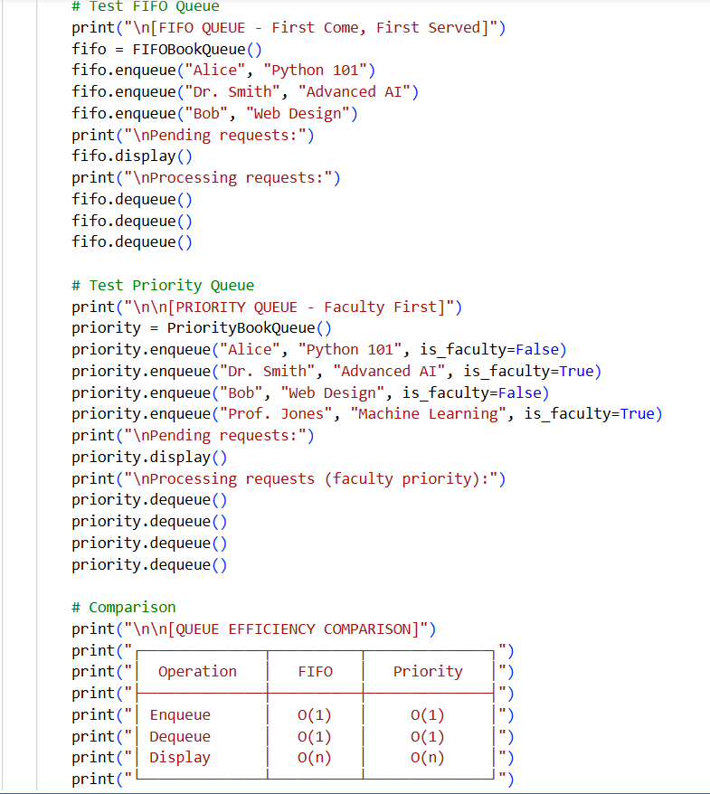  output-  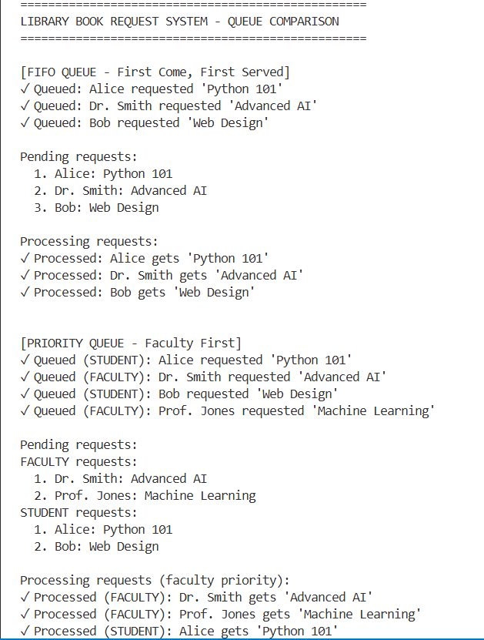  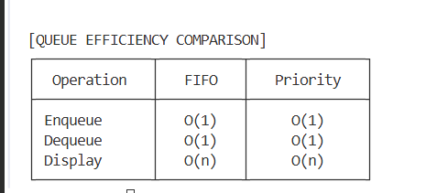  Explanation:-  The Library Book Search System manages book requests using queues. In a normal queue, requests are handled in the order they arrive. To prioritize faculty members, a priority queue is used where faculty requests are served first. This ensures important requests are handled quickly.  Task 3: Emergency Help Desk (Stack Implementation)  Scenario  SR University’s IT Help Desk receives technical support tickets from students and staff. While tickets are received sequentially, issue escalation follows a Last-In, First-Out (LIFO) approach.  Tasks  - Implement a Stack to manage support tickets.  - Provide the following operations:  - push(ticket)  - pop()  - peek()  - Simulate at least five tickets being raised and resolved.  - Use GitHub Copilot to suggest additional stack operations such as:  - Checking whether the stack is empty  - Checking whether the stack is full (if applicable)  Expected Outcome  - Functional stack-based ticket management system.  - Clear demonstration of LIFO behavior.  Prompt:-  Code:-  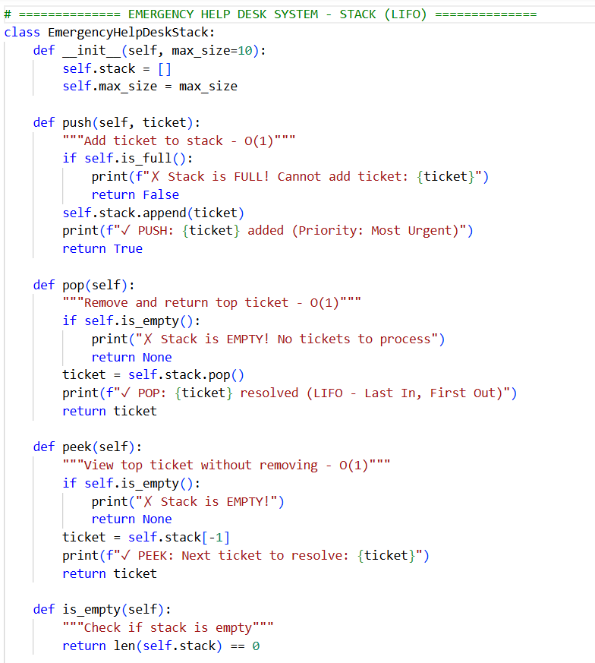  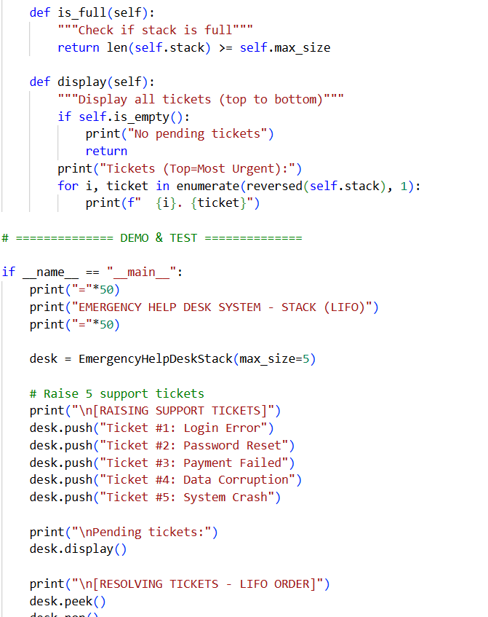  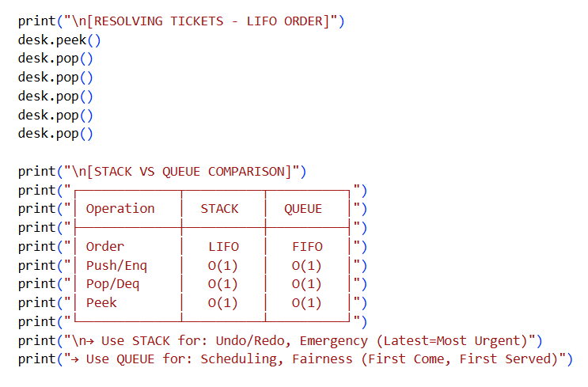  Output:-  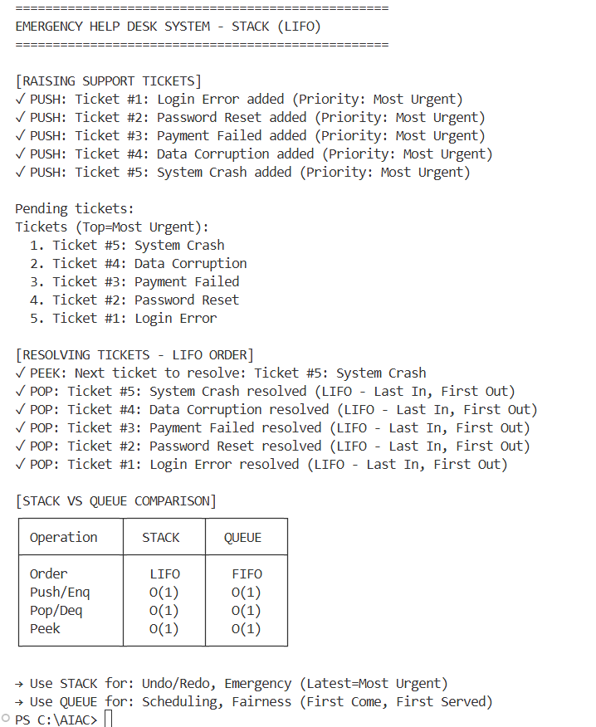  Explanation:-  The Emergency Help Desk system manages technical support tickets using a stack. Tickets are added as they arrive, but the most recent issue is handled first, following the LIFO principle. Stack operations like push, pop, and peek help manage tickets efficiently. This approach is useful for handling urgent or escalated issues.  Task 4: Hash Table  Objective  To implement a Hash Table and understand collision handling.  Task Description  Use AI to generate a hash table with:  - Insert  - Search  - Delete  Starter Code  class HashTable:  pass  Expected Outcome  - Collision handling using chaining  - Well-commented methods  Prompt:-  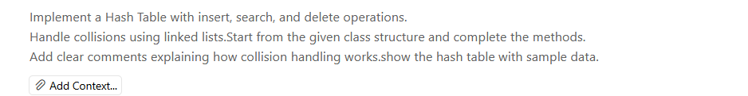  Code:-  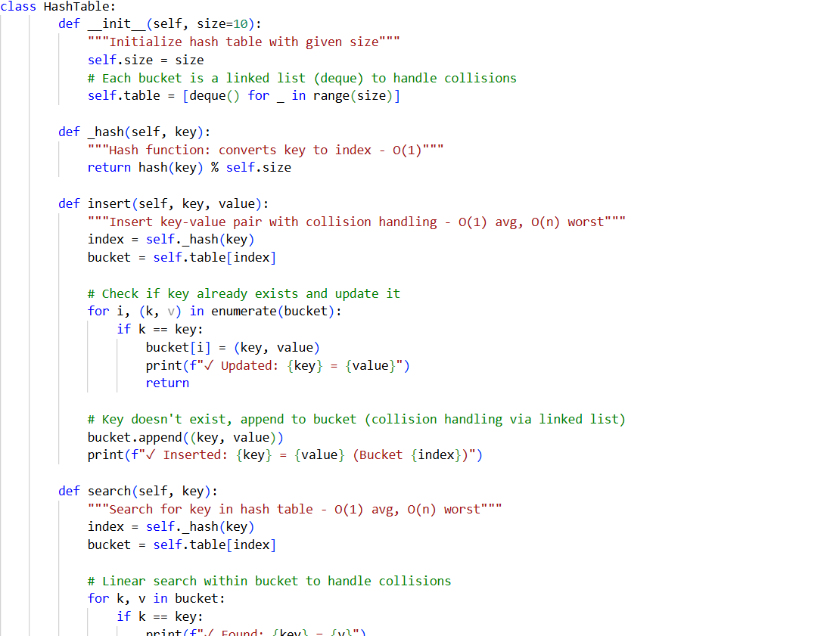  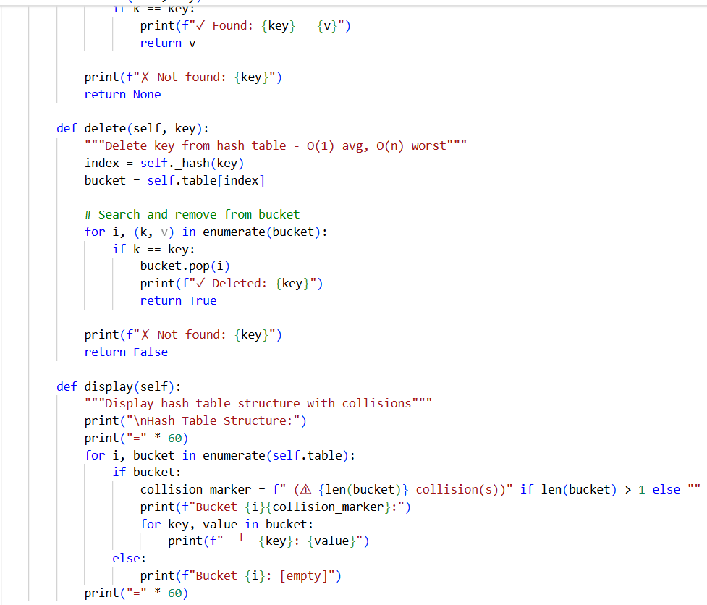  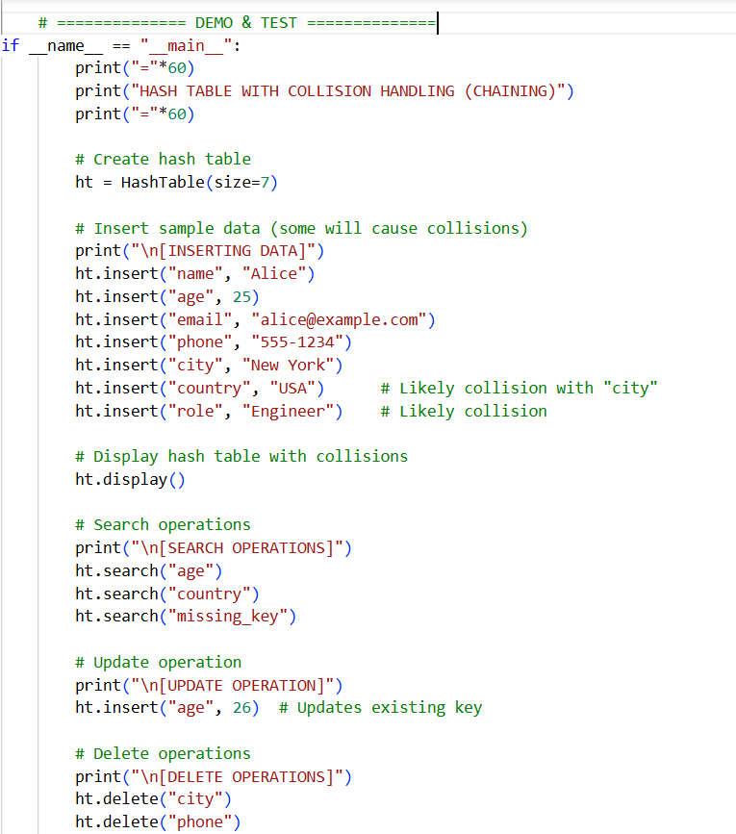  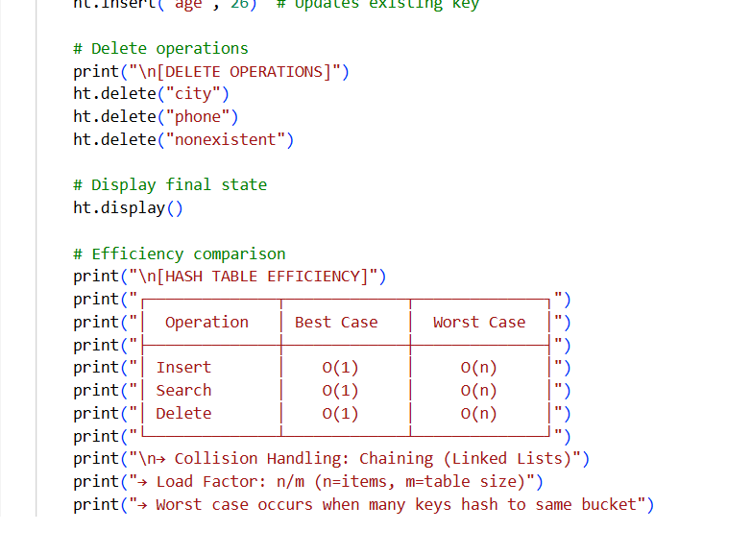  Output:-  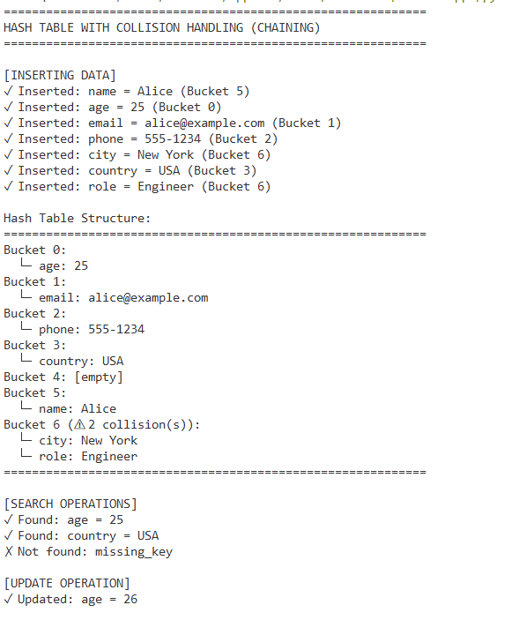  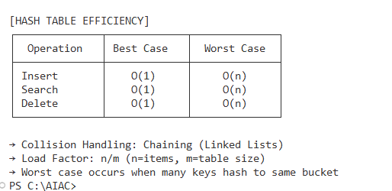  Explanation:-  A hash table stores data using a hash function to map keys to values. Sometimes multiple keys map to the same index, which causes collisions. In this task, collisions are handled using chaining, where multiple elements are stored at the same index using a list. This helps maintain efficient searching and deletion.  Task 5: Real-Time Application Challenge  Scenario  Design a Campus Resource Management System with the following features:  - Student Attendance Tracking  - Event Registration System  - Library Book Borrowing  - Bus Scheduling System  - Cafeteria Order Queue  Student Tasks  - Choose the most appropriate data structure for each feature.  - Justify your choice in 2–3 sentences.  - Implement one selected feature using AI-assisted code generation.  Expected Outcome  - Mapping table: Feature → Data Structure → Justification  - One fully working Python implementation  Prompt:-  Code:-  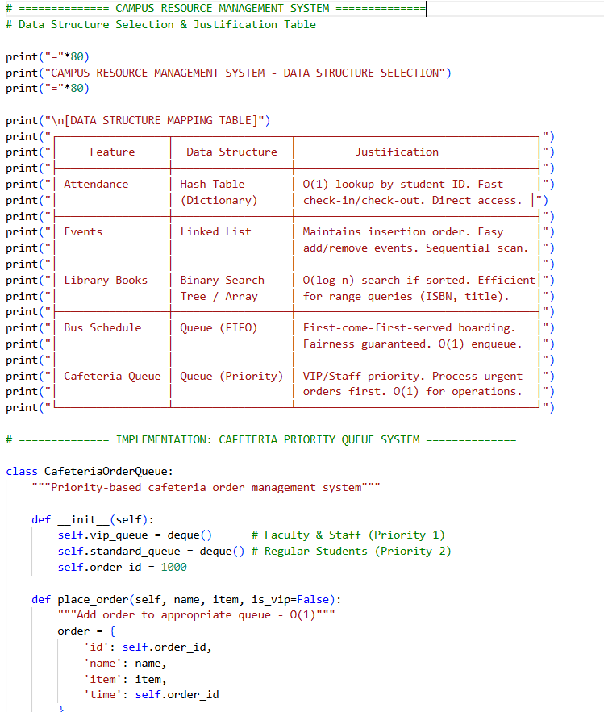  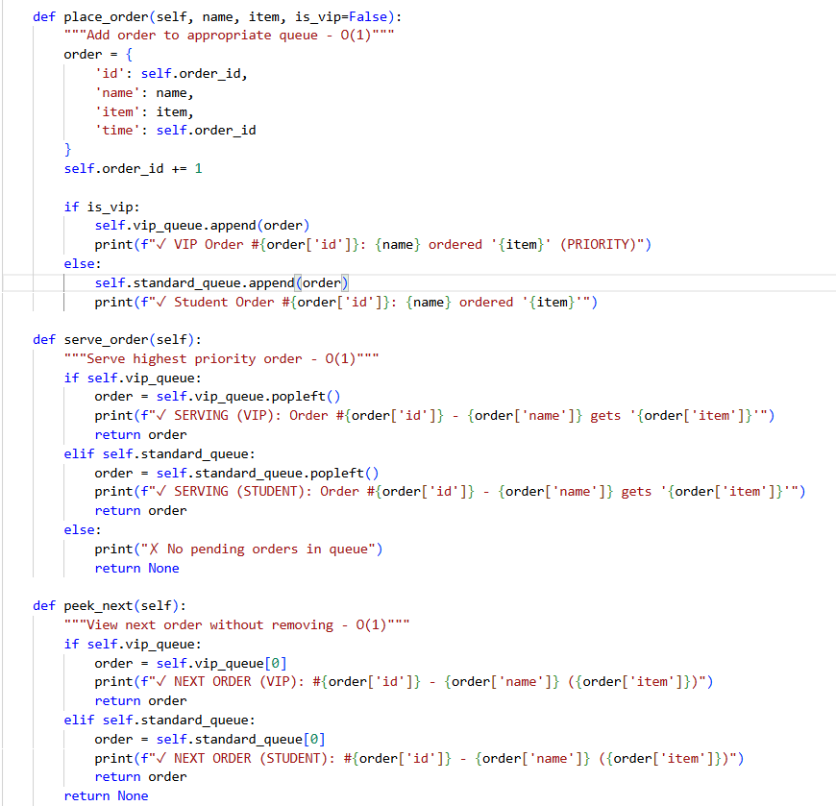  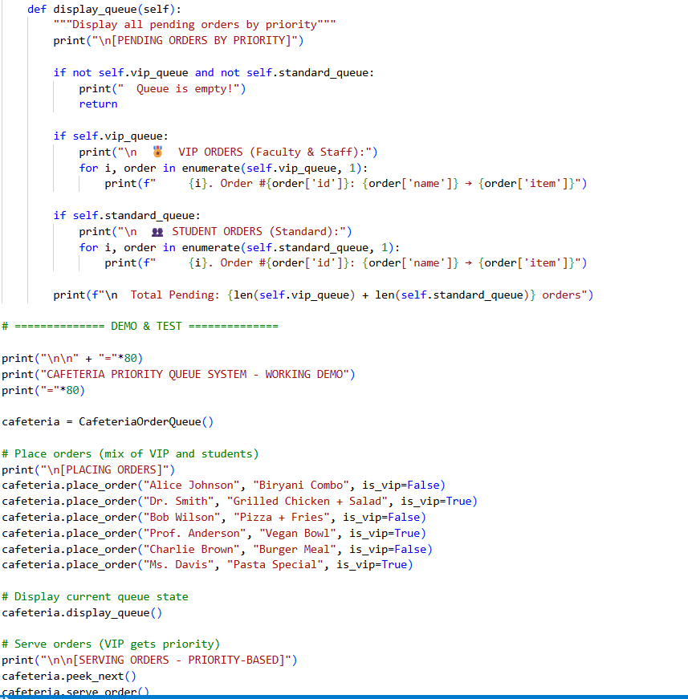  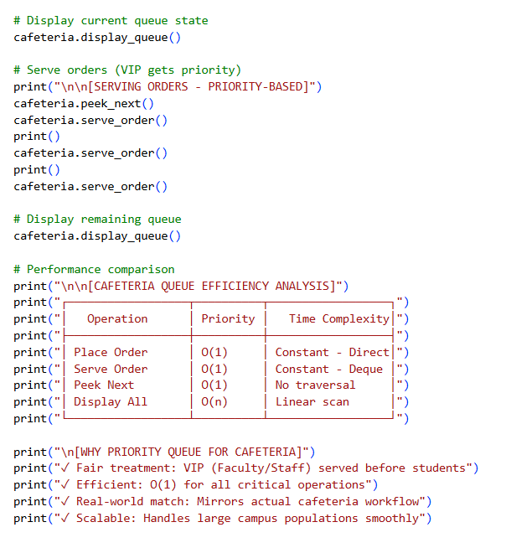  Output:-  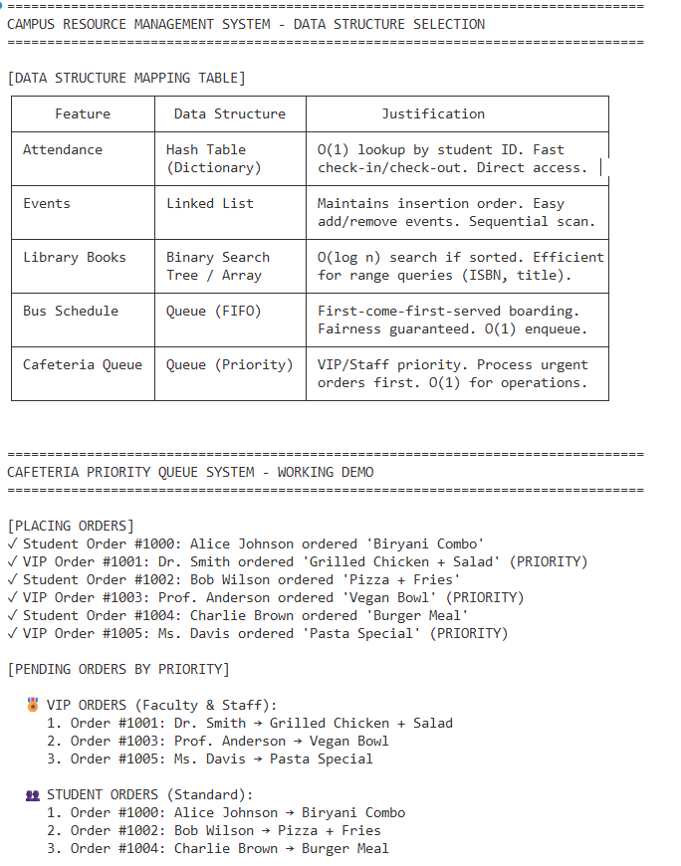  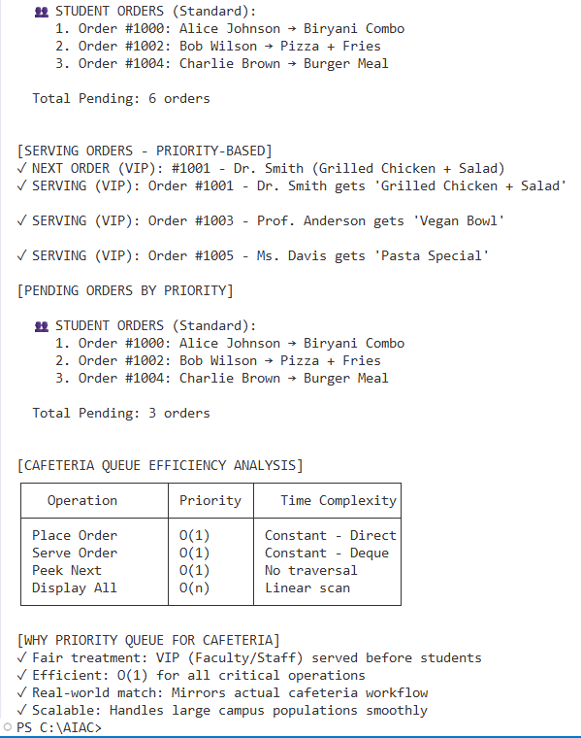  Explanation:-  This task focuses on selecting the right data structures for real-life campus systems. Each feature uses a data structure based on how data is stored and accessed. One feature is implemented using Python to show practical usage. This helps connect data structures with real-world applications.  Note: Report should be submitted as a word document for all tasks in a single document with prompts, comments & code explanation, and output and if required, screenshots. |  |  |  |  |  | Week6 - Wednesday

